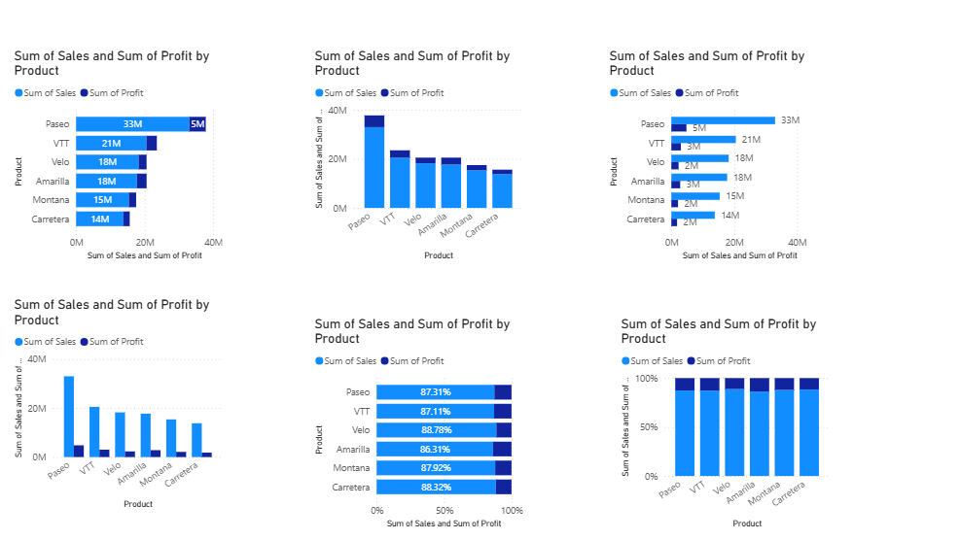

**ASSIGNMENT:3 (03-09-25)**

**COMPARISON OF STACKED, CLUSTERED AND 100% STACKED BAR Charts**

**STACKED BAR CHART**

* **We should go with a stacked bar chart when we need to represent multiple categories.**
* **Since bars are horizontal, they give more space to display multiple categories clearly.**

**CLUSTERED BAR CHART**

* **When we want to compare categories separately, we choose this chart.**
* **Best suited for comparing the performance of sub-categories.**

**100% STACKED BAR CHART**

* **For understanding the percentage distribution across categories, we can opt for 100% stacked bar chart.**

**COMPARISON OF STACKED, CLUSTERED AND 100% STACKED COLUMN Charts**

* **When we want to see overall totals and breakdown across categories, we can use a stacked clustered column.**
* **When we need to compare individual sub-categories, we can go for a clustered column chart.**
* **For understanding the percentage distribution across categories, we can opt for 100% stacked column chart.**

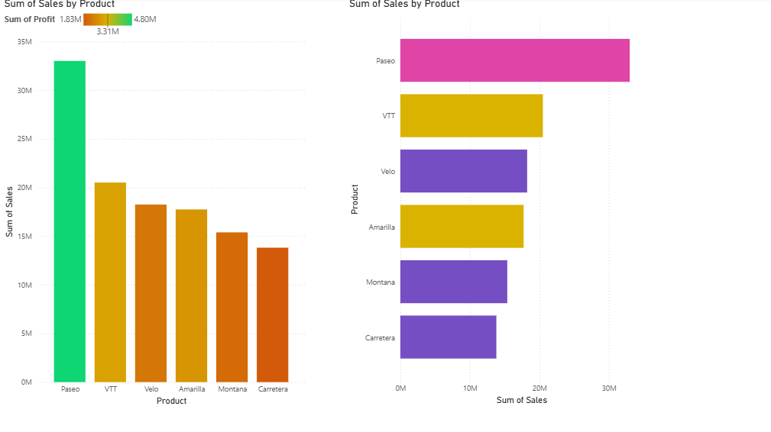

**CONDITIONAL FORMATTING**

**STEPS:**

* **Insert the appropriate chart.**
* **Add fields to the chart.**
* **Click on Format your Visual.**
* **Click on column/bar options.**
* **Under the colour heading, choose fx ( function).**
* **In colour-categories choose format style (ex, gradient)**
* **Choose the field in which we want to show the categories.**
* **Click on the drop-down menu**
* **All data**
* **Choose the field.**
* **Select the format empty values (Don’t Format)**
* **Select the suitable colours (more colour options) for the minimum, centre and maximum values.**
* **All the adjustments will be reflected on the chart.**

**For the second chart, in colour categories, choose format style (ex, Rules)**

* **Highlight values based on boundaries**

**[If value >= and <= the number, we go with Rules Format Style]**

* **Set the boundaries and choose the colours.**
* **Click on OK.**

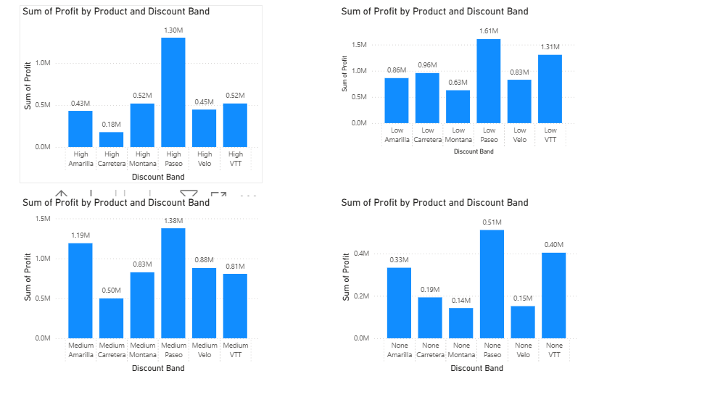

**FILTER**

* **Select the chart in which you want to filter.**
* **Click on the Discount Band drop-down and choose filter types (high, low, medium and none)**
* **SMALL MULTIPLES**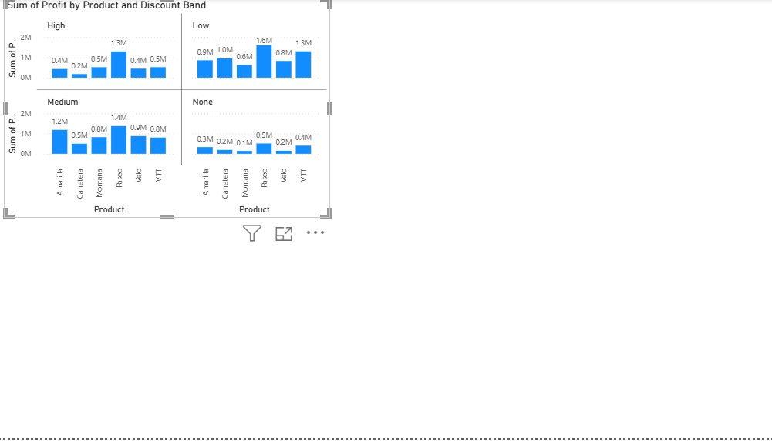
* **Instead of using multiple bar/column charts, we can use the ‘small multiples’ option in the build visual option.**
* **Drag the Discount Band from the data pane to the small multiples field. Then, the chart will be split into a clear side-by-side view.**